**GDD**

- Master Document -

For Pest Control

Lead Developer

Leo Dai

Lead Designer

Leo Dai

UI & UX

Leo Dai

Creative Director

Leo Dai

Table of Contents

**Controls 3**

Mouse + Keyboard 3

**Sketches 4**

Game Concept Sketch 4

Player Sketch 5

**Mechanics 6**

Movement 6

Pests 6

Pest Removal Gear 7

Children 9

Economy 9

CLAIM THE HOUSE 10

CLAIM THE BACKYARD 10

Win Conditions 10

**Timeline 10**

# 

# Controls

## Mouse + Keyboard

* WASD to move
* Mouse to aim
* (More will be added later but it just depends on what movement syste

# Sketches

## Game Concept Sketch

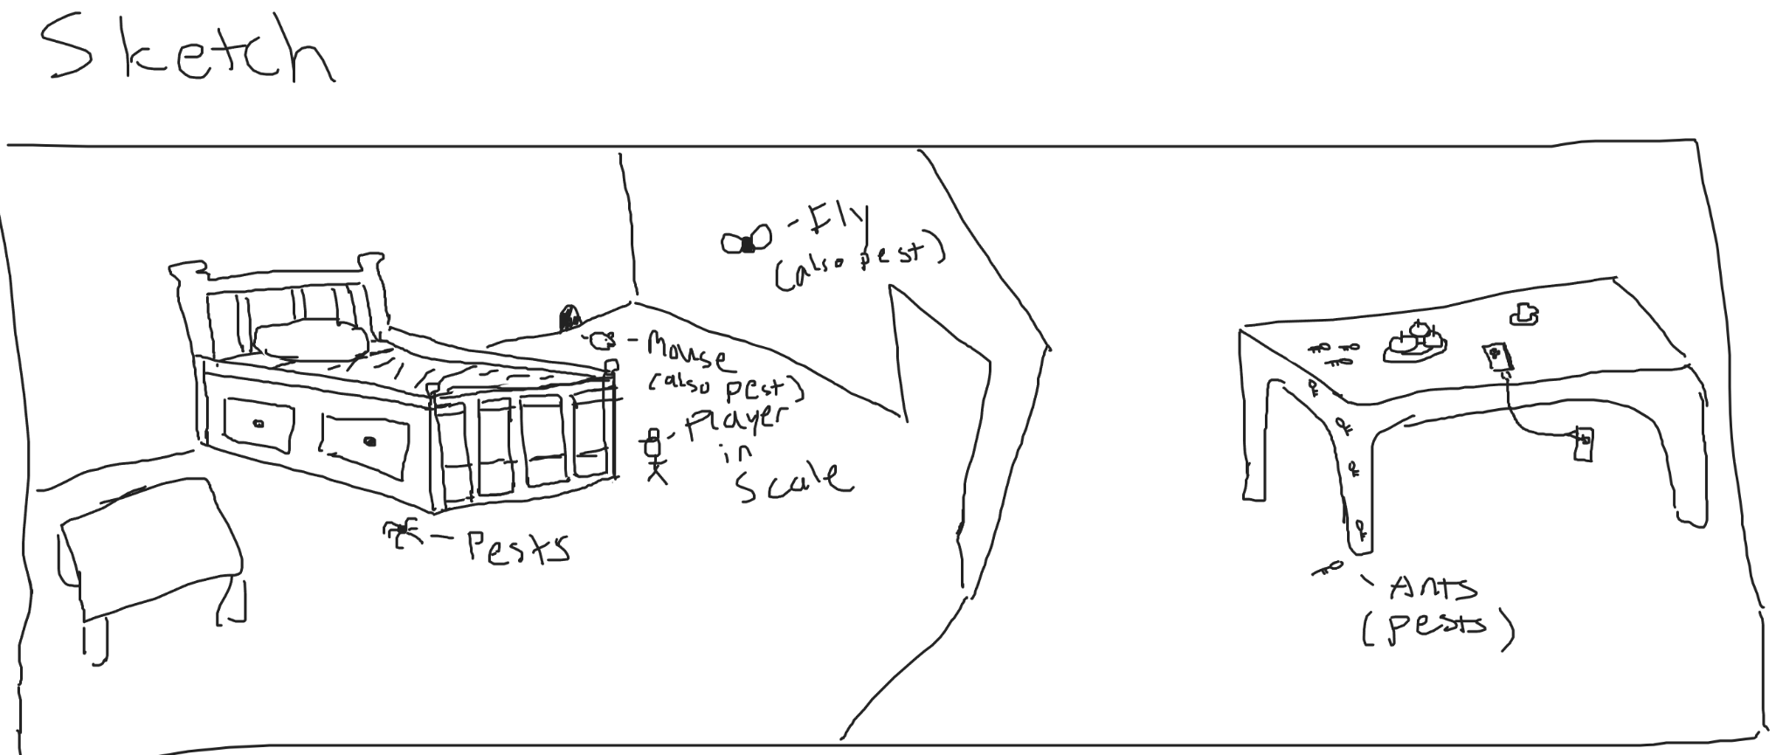

* From the sketch the Player is a pest control agent (product) and his job is to remove all pests from the house.
* Another key aspect is that the Player is sized down to the size of an average action figure toy
* The Pests will include of insects such as ants, spiders, flies and then it will include Beasts such as Mice and maybe more …
* The Setting of the game is in a modern home however this is subject to change. (Potential for more than one map)

## Player Sketch

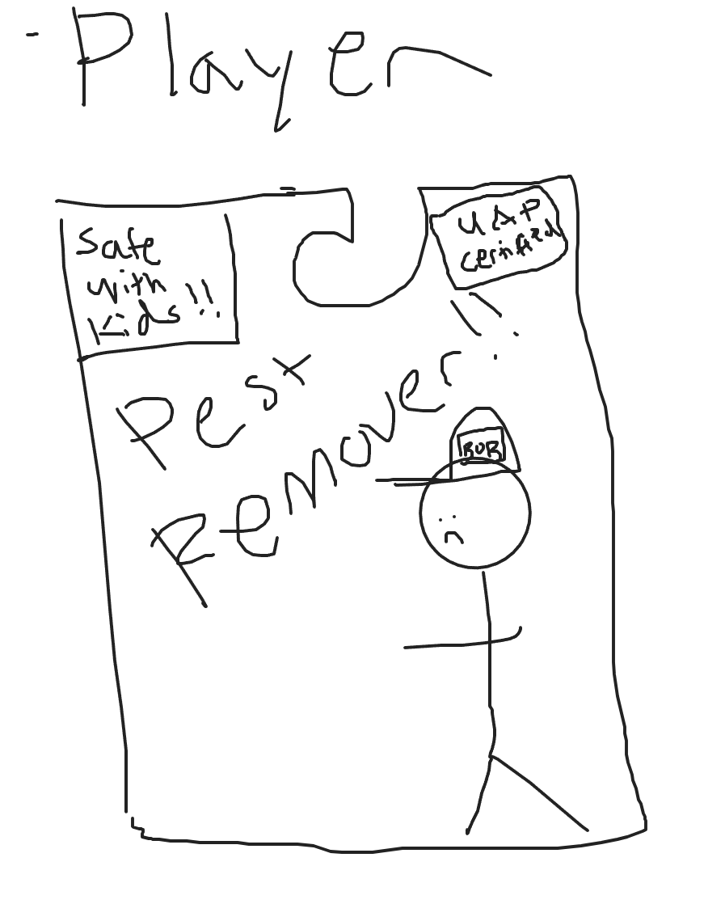

* As we can see the player is pretty small as it comes in an action figure like packaging (subject to change)
* Another key aspect is the regulational tags of (Safe with kids) and (UAP Certified)
  + What these means are subject to change but Safe with Kids will mean that the agent cannot harm children or pose a choking hazard to children (IMPORTANT)
  + UAP Certified will mean that the agent will cause minimal to no damage to the house (ALSO IMPORTANT)
* The agent’s name is Bob if you are wondering

# Mechanics

## Movement

* Movement will be wasd as mentioned in the controls. It will be fairly robust but the player will have other forms of movement (subect to change). Please see the sketch first before seeing the mechanics but the player will need a faster form of transportation to go around the house or room (subject to change) to clear out all the pests.
  + Ideas:
  + One movement opportunity could be grapple hooks cause they are fun. ODM system like attack on titan.
    - This would also involve an energy system for a cooldown or someway to limit how often the player can grapple or dash.
  + Another movement system could be giving the agent a car or motorcycle to get places (or even plane)
  + A lazy way to do it but still good way to do movement would simply be adding dash abilities where your player can either jump really high with a super jump or dash quickly in a direction.

## Pests

* Pests will come in variety in size and quantity but the main ones so far are:
  + Spider
    - Great for those with arachnophobia as spiders will be much larger as the player is the size of an action figure.
    - The spider will have webs and attack like a spider would attack their prety
  + Ticks
    - Very anoyying and also will be super annoying to kill as they are pretty fast.
    - Will be the common pest type and will not be a challenge for the player
  + Fly
    - Flies will be like ticks but they fly making killing them much more anoyying
    - Will be there just to make the player suffer
  + Rat
    - Master Shifu will be a big challenge to fight against primarily because rats will be bigger than the player.
    - Rats will be almost like a mini-boss as they are much more larger and tankier than any insects at all.
    - They also pose much more danger to the player as they can easily outpower the player
    - The rat will have a cheese eating habit so the best way to remove rats will be by using lure’s
  + Wasp Nest (Add if you have the time)
    - So the owner’s were off for vacation for 10 years and a wasp best appeared in the bedroom !!!! It is up to you to remove it.

## Pest Removal Gear

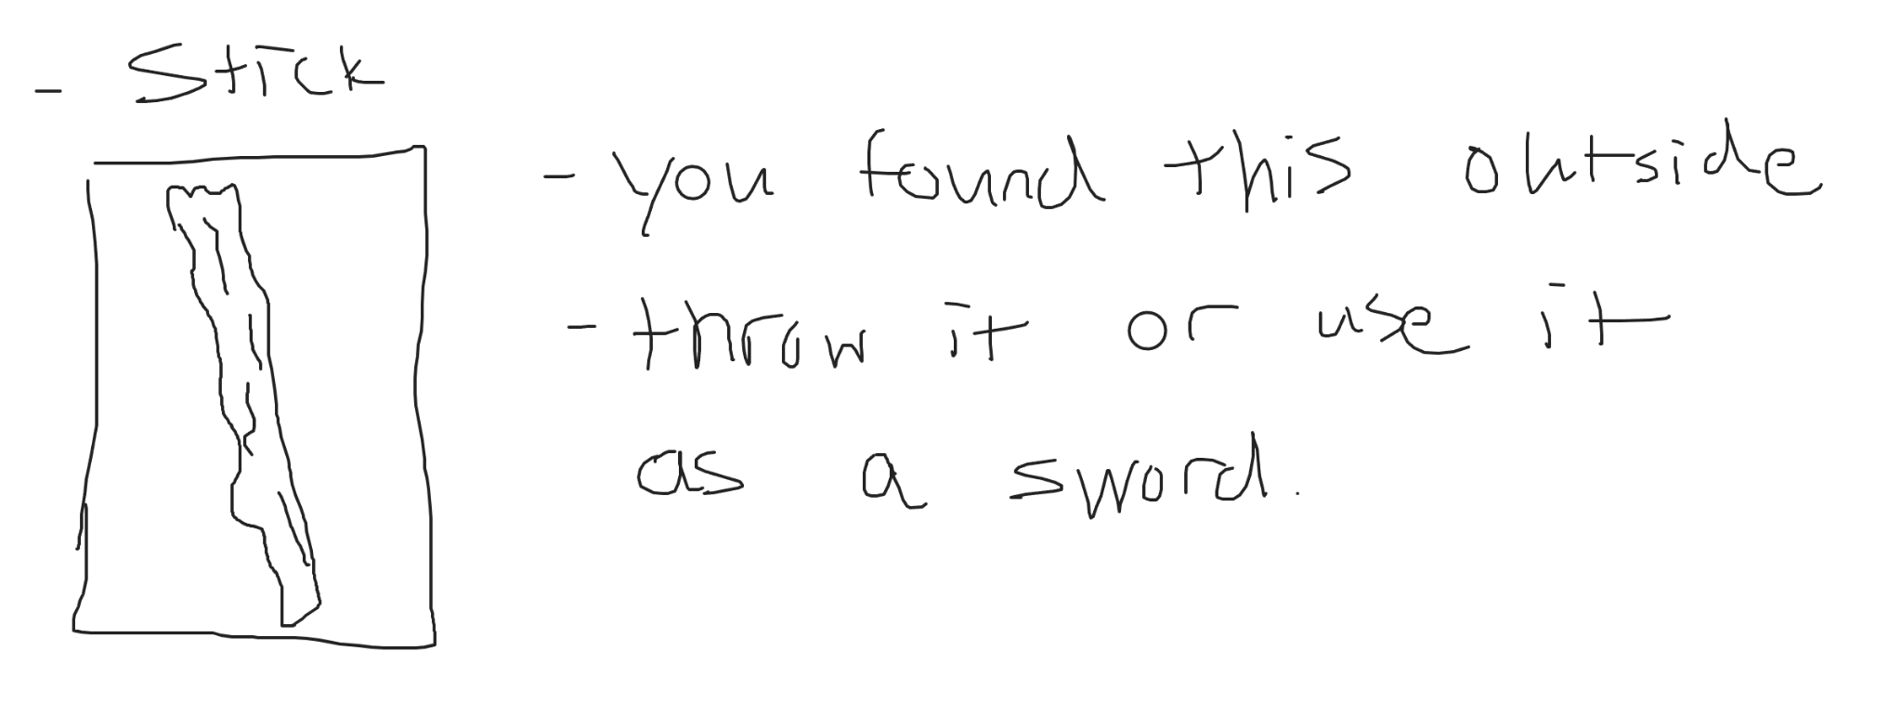

* Free

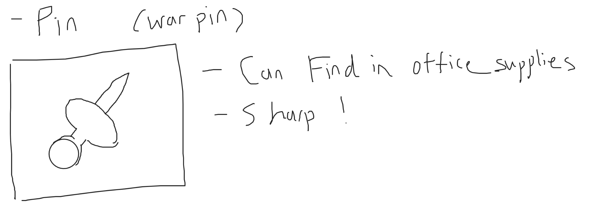

* Pack of 250 for only $8.99

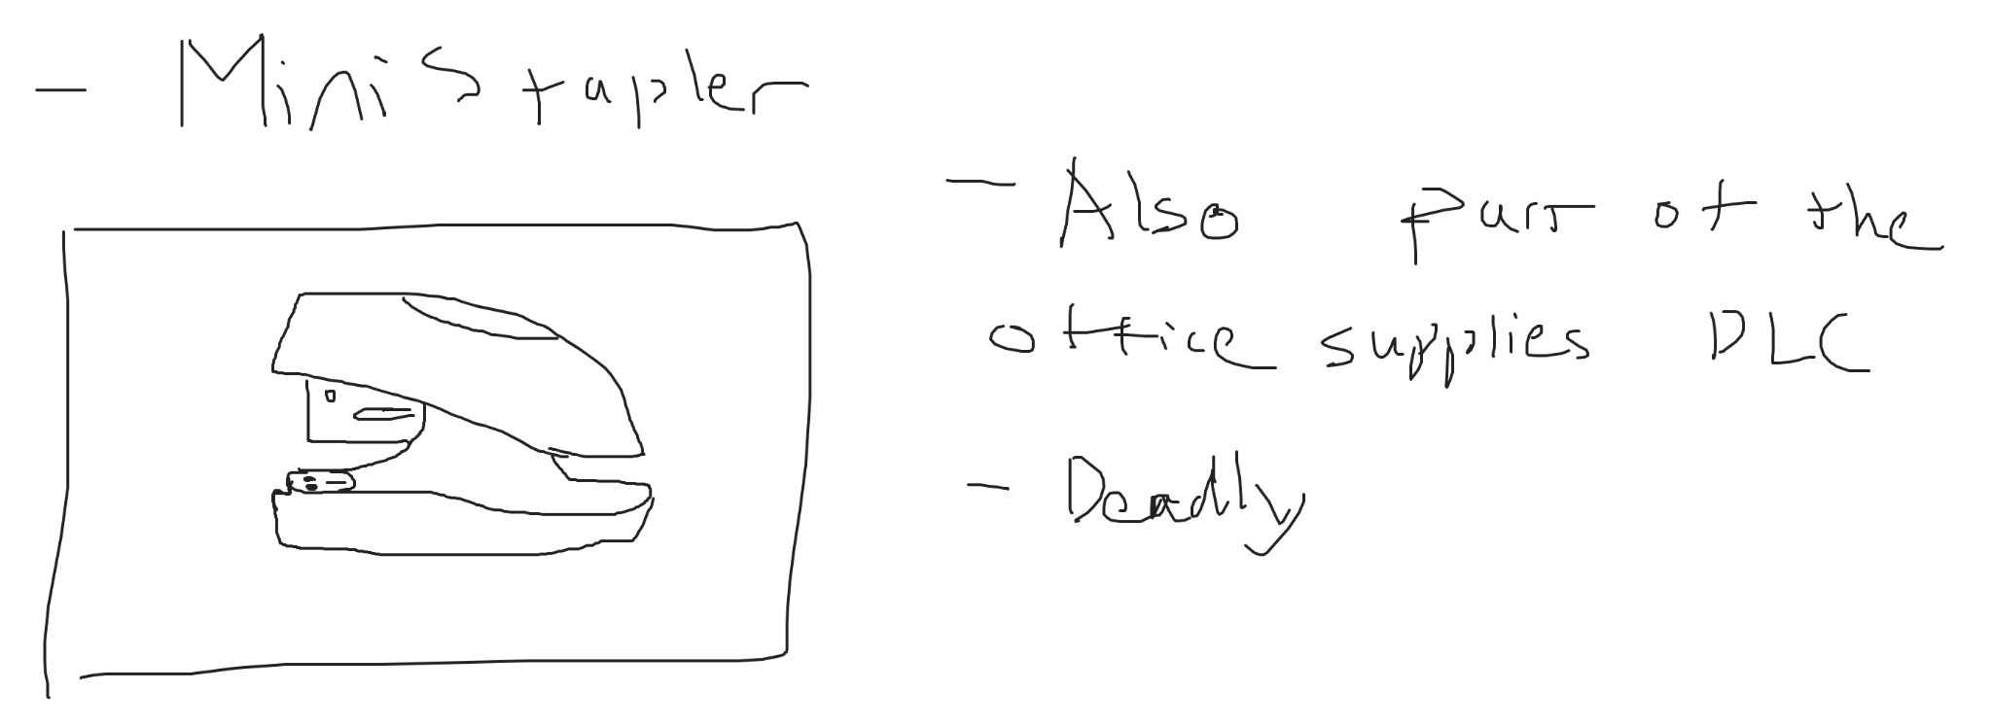

* Costs $20 because of inflation

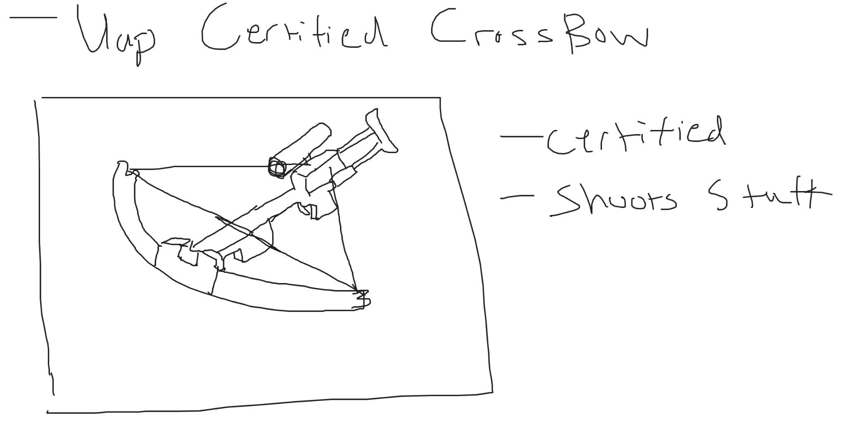

* Costs $1000 dollars because of inflation

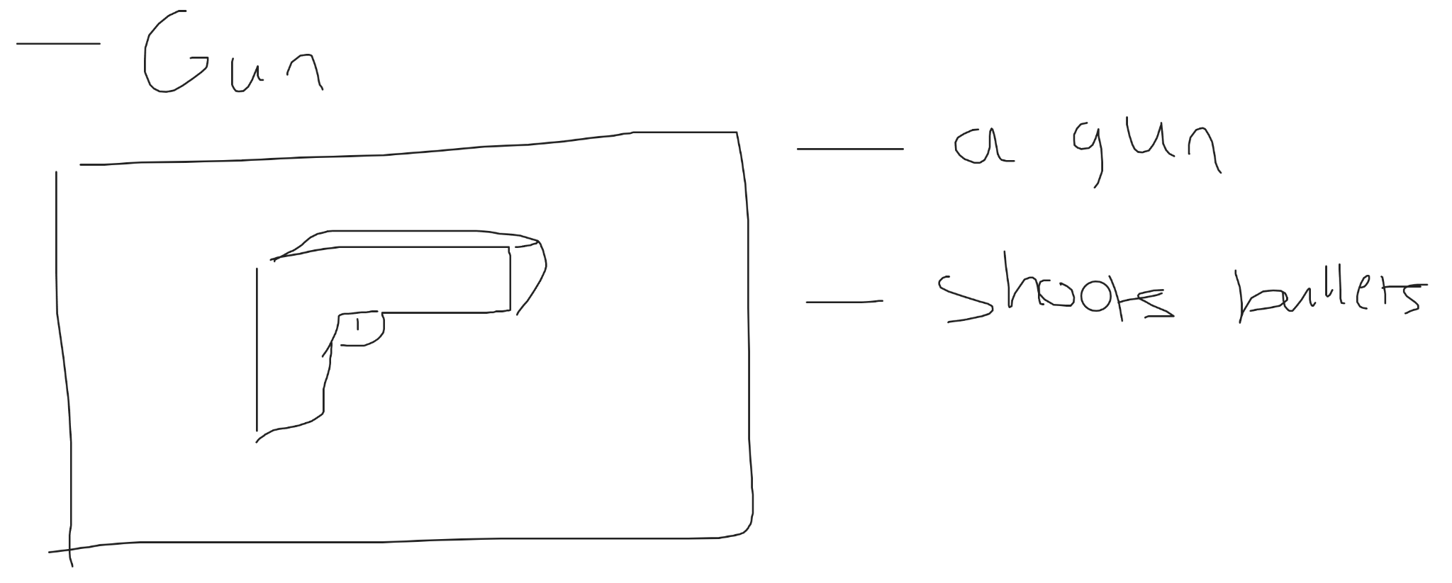

* Costs $5000 dollars because of inflation

## Children

* ADD IF YOU HAVE TIME
* Anoyying critters known as children are here to disrupt your pest removal.
* You have to remain SAFE to children under 7 years and not be a choking hazard. This is a problem especially since the children will try to eat you !!! Pesky Rats.
* One key game mechanic will be trying to avoid being eaten by children so your higherups (the company that created you, you must obey) do not get sued.
* Children will see you and if they become interested in you they will attempt to eat you.
* Dodge them (should be easy because children are stupid)

## Economy

* I know this is just a simple pest controller game but economy will play a big part in this game. You will get money from many ways but it will mainly be by completing ur tasks to the best grade quality as possible.
* Every room you clear or pest you remove (subject to change) will send a grade of A-F determining how good of a job you did when removing the pest. The company will see the report and send you money depending on how good you did.
* With said money you can buy better weapons to exterminate pests
* You can also buy cyborg modifications to enhance your power
* These can all be bought via the company.
* ADD BELOW IF YOU HAVE TIME
* HOWEVER the company is not the only way you can make money.
* Another way to make money is via the black market cause this game has to have a black market.
* You can buy money printers from the black market (as a side hustle) and print money to earn cash.
* YOU maybe asking?? Wouldn’t the company see you doing this and have you shutdown. Yes they will get mad but it will be bad for their pr team so they do not do anything.
* However just because the company does not care doesnt mean that the owner’s of the house won’t care. The house owners will occasionally without notice check on your work and if they see money printers they will confiscate it upon sight. (You cannot fight them because ur just a puny action figure sized robot) (Assume they have 12 guage shotguns)

## CLAIM THE HOUSE

* ADD IF YOU HAVE TIME
* With enough money the ultimate goal for you is to remove the house from ALL PESTS. (This is part of your programming) You have seen and deemed the human and dog inhabitants of the house are unfit to live there and must be removed.
* You can do this two ways. One is to buy the house off of them (literarlly impossible u need like 2 million dollars)
* Or you can remove them.

## CLAIM THE BACKYARD

* ADD IF YOU HAVE TIME
* Battle against endless pests in the backyard. (survival game mode)
* (Add if you have the time)

## Win Conditions

* This game is a more sandbox like game where you just upgrade your character and dowhatever. You can make money and buy better gear but overall if you just wanna sleep you can do that too.
* However if you do claim the house you are considered a supreme ruler and hailed as king so thats also cool.

# Timeline

Overall the game is pretty ambitious asking for alot to be modeled, rigged, animated etc. So organizing the production will be very worthwhile.

Production will be separated into two brackets: Visual and Non-Visual

## Non-Visual

* Movement Basics
  + Code together a wasd, jump movement system with a fps camera.
  + This should be pretty easy and should take less than a day to do.
  + (1 - 2 hours aprox)
* Movement Advanced
  + Code an advanced movement system depending on whether you want to do a aot/odm inspired grapple hook system or a detailed dash ability to move.
    - Would take alot longer to complete as it involves polishing and making sure the movement system is smooth.
    - (6 - 12 hours aprox)
  + Or you could add mini vehicles to the game where the player can drive in a car or motorcycle or fly a plane to move around the room.
    - Would take alot longer considering you have to script and model a polished vehicle. Could watch a tutorial to cut down on time but would take much more time than a dash/aot movement system.
    - (12 - 36 hours aprox)
* Pests
  + Main Pest Script
    - Would involve the very basics that all pests would have in common. These include:
      * A health system
      * A pathfinding system
      * A patrol/idle system
      * A run system
    - Note all these systems are replaceable like for example a spider would have a much different patrol/idle system than an ant.
    - (6 - 16 hours aprox)
  + Spider
    - Would involve modifying the main pest script to add:
      * Web sligning action
      * Custom idle/patrol system
      * A movement system based off web aligning
      * A more refined behavior system
    - (4 - 6 hours aprox)
  + Ticks
    - Would involve modifying the main pest script to add:
      * Changes to behavior i.e. making it always flee when it sees the player.
    - (1 - 2 hours aprox)
  + Fly
    - Would involve modifying the main pest script to add:
      * Custom movement script that makes it fly instead of crawling
      * Custom behavior (google search fly behavior)
    - (1 - 3 hours aprox)
  + Rat
    - Would involve modifying the main pest script to add:
      * Custom behavior tuned to cheese loving
      * Attack system
    - (4 - 6 hours aprox)
  + Wasp
    - Would take alot of time because you need to add:
      * Flying movement that is more aggressive
      * Attacks that are visible yet hard to fight against
      * It would be hard
    - (8 - 12 hours aprox)
* Pest Removal Gear
  + Throwing Script
    - This script lets you pickup items and throw them
    - (1 - 2 hours aprox)
  + Swing Script
    - Simple weapon swing if I add swords
    - (0.5 -1 hour aprox)
  + Poke Script
    - Weapon poke
    - (0.5 - 1 hour aprox)
  + Shooting Script
    - Will use proceduralized raycasting as I want the the projetciles to have weight.
    - (1 - 3 hours aprox)
* Children
  + Custom pathfinding and behavior but might still implement pest script.
  + (12 - 24 hours aprox)
* Economy
  + Scripting economy is not that bad with weapon shop and all that
    - (0.5 - 1 hour aprox)
  + Scripting money printing system and a way for the owners to catch you money printing
    - Hard
    - (8 - 24 hours aprox)
* Claiming the house
  + Easy
  + (0 hour)
* Claim the backyard
  + Not bad
  + (0.5 - 2 hours aprox)

## Visual

* Player
  + Will be fps but will still have to model the player’s hands and the box that the player comes in
  + (1 - 2 hours aprox)
* Pests
  + Model in blender
  + Setup Rig and Setup Animations
  + Or you can just get a free asset of unity (last resort)
  + Spider
    - (8 - 12 hours)
  + Tick
    - (3 - 8 hours)
  + Fly
    - (3 - 8 hours)
  + Rat
    - (6 - 10 hours)
  + Wasp
    - (8 - 12 hours)
* Pest Removal Gear
  + Model in blender
  + Setup firing animations or use animations
  + Stick
    - (1 - 3 hours)
  + Pin
    - (1 - 3 hours)
  + Mini Stapler
    - (4 - 12 hours)
  + Crossbow
    - (8 - 16 hours)
* Children
  + Model in blender
  + Setup rig and animations
  + Probally will have to get this off a free asset
  + (12 - 24 hours)
* Money Printer
  + Model in blender
  + Setup rig and animations
  + (12 - 18 hours)
* GUI
  + Gui for basic health/ammo count/energy left
    - (4- 8 hours)
  + Gui for economy/shop/black market
    - (8 - 12 hours)
* Map
  + Biggest Undertaking (24 - 40 hours)

# Timeline Visualized

[Link to Google Spreadsheet](https://docs.google.com/spreadsheets/d/143T_akW3LeVX8Kwl683EpLScPgRT0mdS7m50UywApvM/edit?usp=sharing):

https://docs.google.com/spreadsheets/d/143T_akW3LeVX8Kwl683EpLScPgRT0mdS7m50UywApvM/edit?usp=sharing